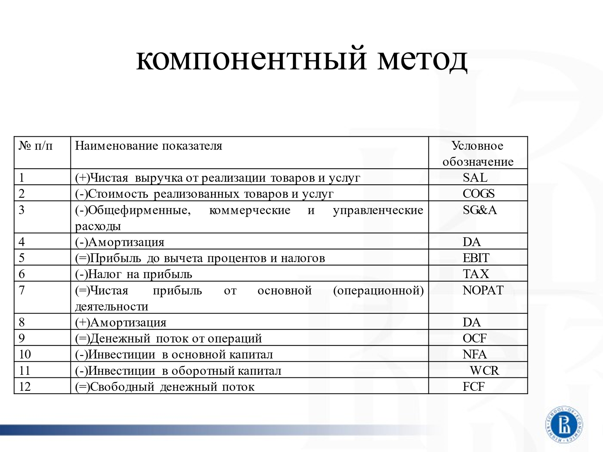

SAL – Sales
COGS – Cost of Goods Sold
SG&A – Selling, General & Administrative Expenses
DA – Depreciation and Amortization
EBIT – Earnings before Interest and Taxes
NOPAT – Net Operating Profit after Taxes
OCF – Operating Cash Flow
NFA – Net Fixed Assets
WCR – Working Capital Requirements ( = NWC – Net Working Capital)
FCF – Free Cash Flow

